**Exercise models for web Pen-Test system**

**MODEL A step by step installation**

|  |  |  |  |
| --- | --- | --- | --- |
| Resources | Sender(attacker) | Receiver(victim) | Homepage |
| OS | Ubuntu | Windows |  |
| IP address |  |  |  |
| URL |  |  | http://localhost:8080/ |
| Web browser | Ubuntu | Chrome |  |
| CSS language |  |  |  |
| Web server |  |  | Apache |
| Web application |  |  | PHP |
| DB server script |  |  | MySQL |

**Install web server (if necessary) =>** **screen shot and explain in detail**

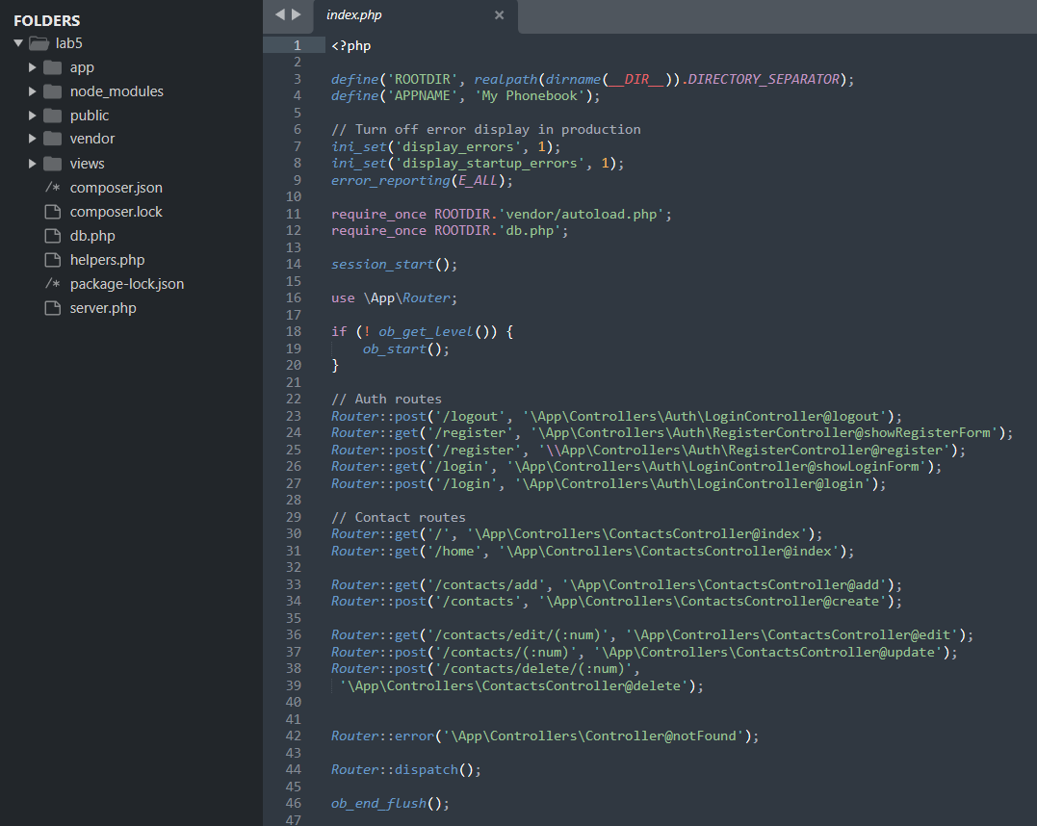

**Figure 1: File index.php inside web server setup folder**

1. **Install web application => screen shot and explain in detail**

The web application is a Phonebook. Each user will have their own list of contacts and information.

When user log in to the system, they can create, edit, delete their list and manage their contacts easily.

1. **Install SQL DB server =>** **screen shot and explain in detail**

Inside database, there are two table, one for users information, other for contacts informations.

1. **Develop client log in screen (if necessary) =>** **screen shot and explain in detail**

**Figure 2: Client login screen**

If user is already login then it won’t show this login form. Otherwise, it collect data such as message, form, errors.

Then it will echo these data to show in client login screen.

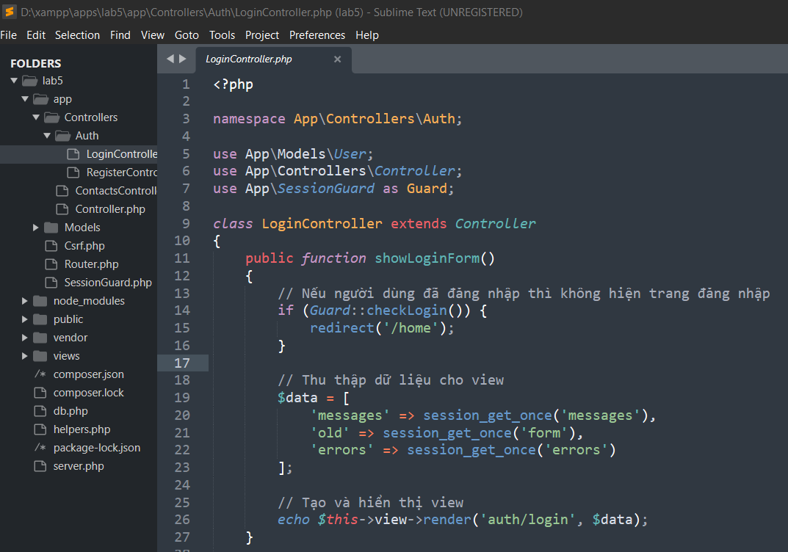

**Figure 3: Function to show login form**

Login function will collect information that user entered login form and check if it has been in User table of database.

It will print an error in the screen if it can’t find matching email or password. If all the information matching, it will direct to home page.

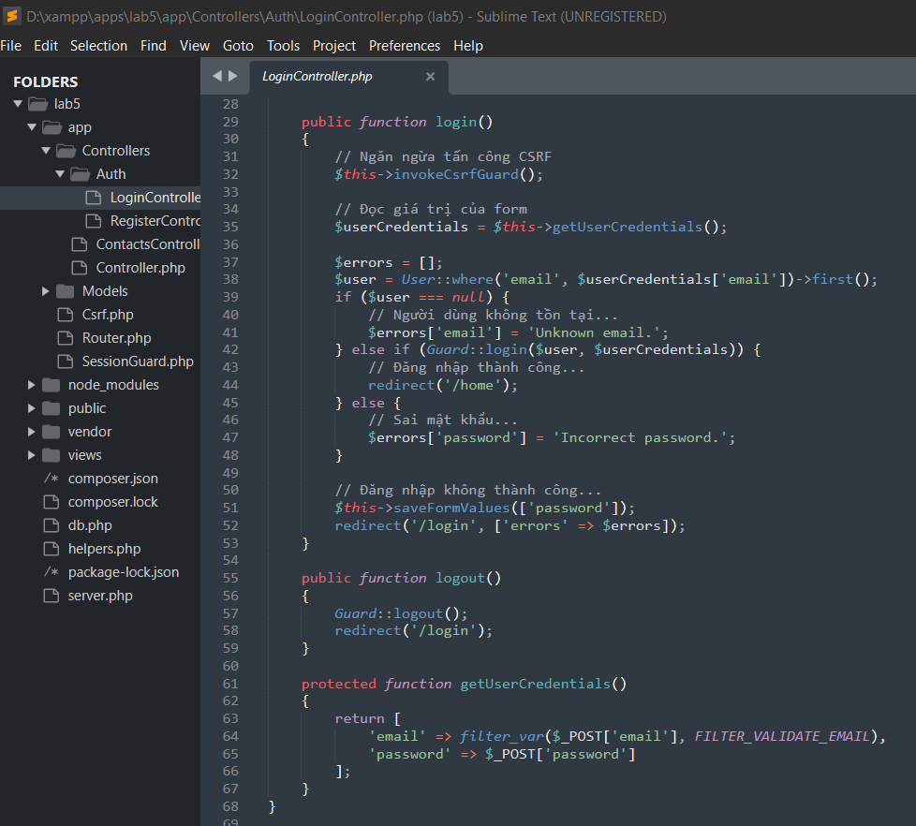

**Figure 4: login function and getUserCredentials function**

1. **Creat SQL DB table(sharing with group table or not?) =>** **screen shot and explain in detail**

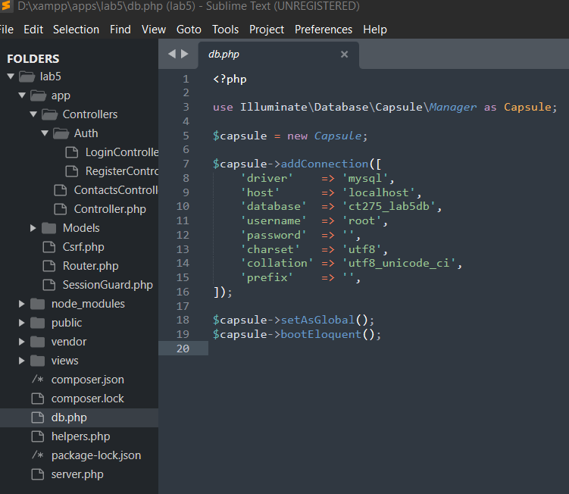

**Figure 5: Database configuration file**

1. **Connection test from client to web application**

**Figure 6: Login successfully with new created account**

**Model B step by step installation**

|  |  |  |  |
| --- | --- | --- | --- |
| Resources | Sender(attacker) | Receiver(victim) | Homepage |
| OS |  |  | Windows |
| IP address |  |  | 127.0.0.1 |
| URL |  |  | Localhost:80/ |
| Web browser |  |  | Microsoft Edge |
| CSS language |  |  | Bootstrap |
| Web server |  |  | Apache |
| Web application |  |  | PHP |
| DB server script |  |  | PHPMyAdmin |
| Others |  |  |  |

**Install web server (if necessary) => screenshot and explain in detail**

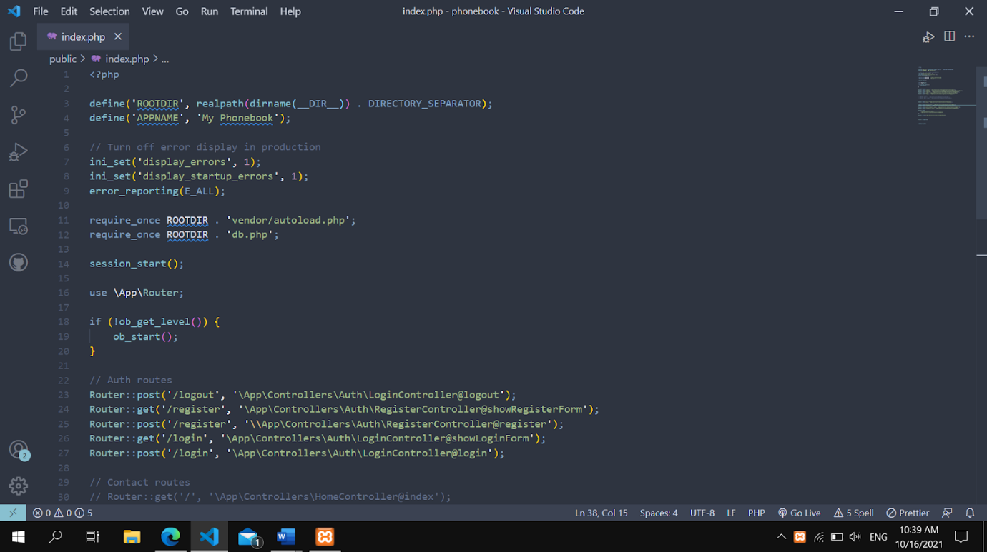

Figure 1: My Web Server

1. **Install web application => screenshot and explain in detail**

Figure 2: My Web Application PhoneBook

1. **Install SQL DB server => screenshot and explain in detail**

I use phpMyAdmin with SQL language to store the database of web application PhoneBook.

Figure 3: SQL Database Server – PHPMyAdmin

1. **Develop client login screen (if necessary) => screenshot and explain in detail**

Login Page allows users to login to the web application PhoneBook using email address and password

1. **Create SQL DB table(sharing with group table or not?) => screenshot and explain in detail**

My PhoneBook created 2 table:

+ contacts: store users information includes name, phone, notes,..

Figure 5: SQL DB – contacts table

+ users: store users’ identification using for login includes name, email, passwords,..

Figure 6: SQL DB – users table

**Create test data(ID,PW data,sharing with group table or not?) => screenshot and explain in detail**

I used the Register Page to test data, this page allows users to register a new account, which includes name, email address, password and comfirm password in order to login to Web Application

Figure 7: Register Page

1. **Connection test from client to web application**

I used the Login Page to connect web application from client, I entered email address and password which I registered to login to PhoneBook

When the input values which I entered are both true, so I can move on to the Home Page (Contacts) of the web application

**MODEL** C **XAMPP** **framework**

1. Install web server (if necessary) => screen shot and explain in detail:

Install XAMPP framework

Visit the website [https://www.apachefriends.org/index.html](https://translate.google.com/translate?hl=en&prev=_t&sl=vi&tl=en&u=https://www.apachefriends.org/index.html) to download:

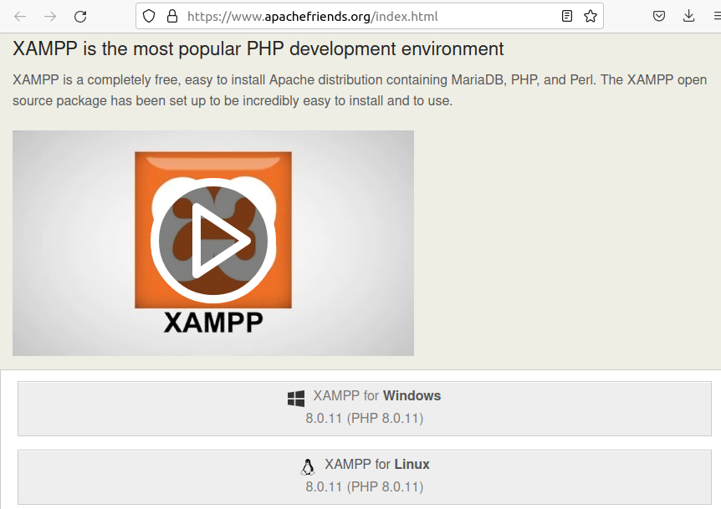

After downloading, we proceed to install:

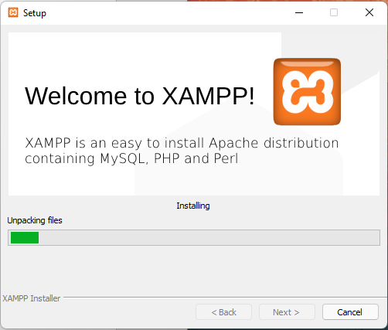

After it is installed, we restart Xampp and go to http://localhost to open the Xampp Web Server interface on Windows

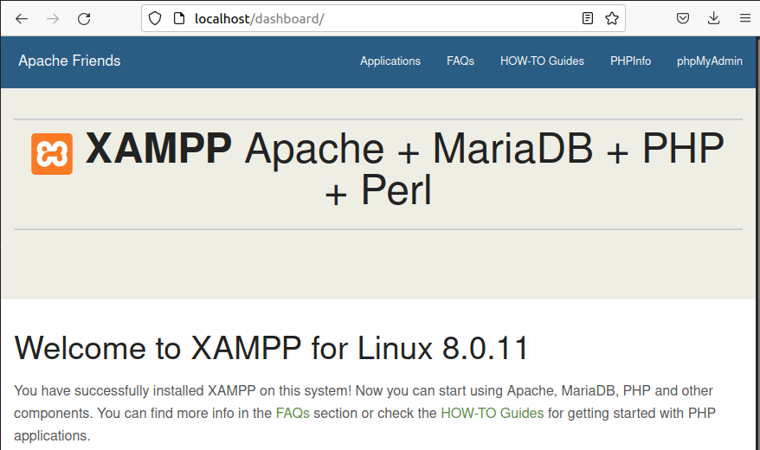

1. Install web application => screen shot and explain in detail

To deploy my phonebook website to Webserver (XAMPP), I need to move the phonebook folder to xampp/htdocs. Go to localhost/.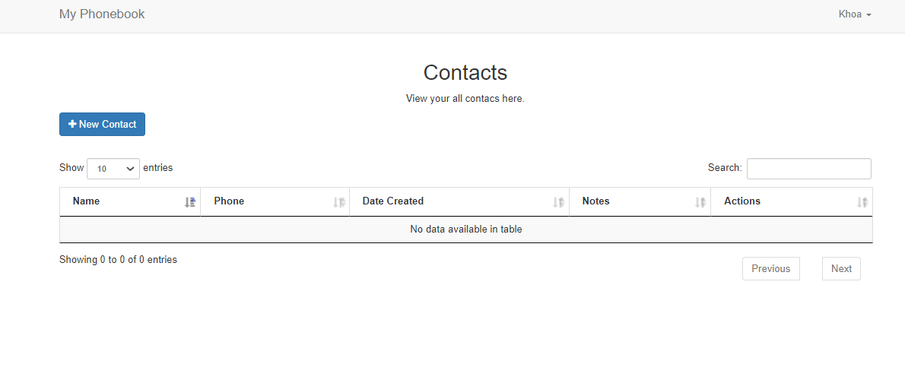

1. Install SQL DB server => screen shot and explain in detail:

Here I use Mysql (MariaDB) which is installed with XAMPP:

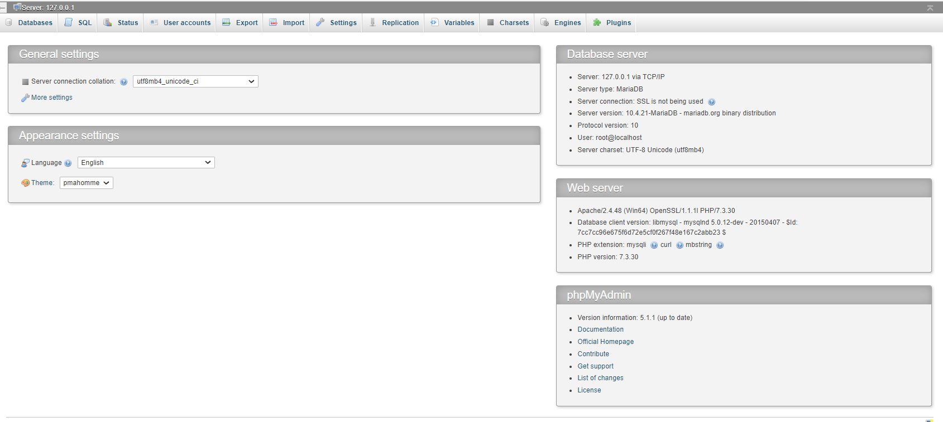

1. Develop client log in screen (if necessary) => screen shot and explain in detail

Create the login interface as follows:

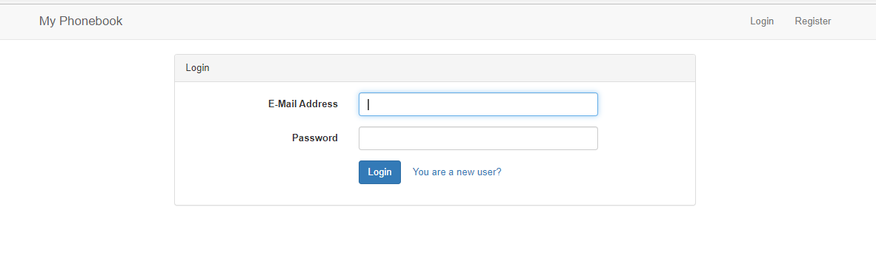

The logic code part, I handle á follows

* Read the value of form

Log in handling:

Create SQL DB table (sharing with group table or not?) => screen shot and explain in detail

Here, I create a database named users(id, username, password, email).

1. Create test data (ID, PW data, sharing with group table or not?) => screen shot and explain in detail

I create data like this: id:1234; username: admin; password: admin; email: admin@gmail.com

1. Connection test from client to web application



